

**Progress report**

# Detecting Parkinson’s disease using Vocal Data from Patients

**Applied Probability and Statistics for Engineers**

**INDU 6310**

**Submitted to: Dr. Amar Sabih**

**Group members:**

**Abdulah Alhoothy: 40075668**

**Muhammad Haris: 40150933**

**Qamar Bani**-**Melhem: 40109566**

**Sourav Patne: 40137125**

**Yaoxin Li: 40092820**

**Concordia University**

**Winter 2020**

**Abstract:**

**TO BE WRITTEN LAST**

**Introduction**

A person who has Parkinson disease or needs a diagnosis of Parkinson disease must pass through various stages of tests. These tests are designed by specialist doctors with their teams; to better understand the severity level of Parkinson’s disease.The aim of our study is to discriminate healthy people from people with Parkinson‟s disease (PD) by detecting dysphonia. Each Patient out of 32 passed through an average of 6 iterations of voice tests. The diagnosis stage or data collection stage involves the application of pre-designed and verified measurement methods to all the speech signals. The diagnostic was performed using the software for better accuracy and precision of the data.

Neurological disorders, including Parkinson‟s disease (PD), Alzheimer‟s and epilepsy, Have a big affect on patients' lives and their families profoundly. Parkinson‟s disease affects over one million people in North America alone.

Research has shown that approximately 90% of PWP exhibit some form of vocal impairment [2, 3]. Vocal impairment may also be one of the earliest indicators for the onset of the illness [4], and the measurement of voice is noninvasive and simple to administer. Thus, voice measurement to detect and track the progression of symptoms of PD has drawn significant attention [5, 6].

**Problem Description**

**WRITE FIRST (1)**

**Dataset**

For the study of Parkinson disease 32 people as a patient were selected. The period since diagnosis with PD is from 0 to 28 years, and the subjects ages are from 46 to 85(mean 65.8, standard deviation 9.8). multiple phonation tests were taken by the subjects (Averages of six phonations were recorded from each subject) ranging from one to 36 seconds in length

The Phonations were recorded by a Multi-Dimensional Voice Program (MDVP) is the premier software tool for quantitative acoustic assessment of voice quality of a patient under observation in the laboratory, it has a capability of calculating more than 22 parameters on a single vocalization input by the patient voice signal. Based on multiple testing and verifications with normal and disordered voices, MDVP software is exclusive in its ability to work correctly over an extensive variety of pathological voices. Although amplitude normalization affects the calibration of the samples, the study data was s focused on measures insensitive to changes in absolute speech pressure level. Thus, to ensure robustness of the algorithms, all samples were digitally normalized in amplitude prior to calculation of the measures.

The data chosen for the project had several parameters:

* MDVP (FO): Fundamental frequency (Fo) is the vibratory rate of the vocal folds. It can be measured in hertz or cycle per second (CPS). Average fundamental frequency during a conversation for males ranges from 100 to 150 Hz, whereas for females it ranges from 180 to 250 Hz.
* MDVP(FHI): maximum FO
* MDVP(FLO): minimum FO
* MDVP (Jitter %):Jitter is a measure of frequency instability. A normal voice has a small amount of instability during sustained vowel production Normal instabilities are influences by tissue and muscle properties. It is measured in %.
* MDVP (Jitter abs): Absolute jitter.
* MDVP (RAP): Relative measure of the pitch disturbance.
* MDVP (PPQ): Pitch perturbation quotient
* MDVP (Shimmer): Shimmer is a measure of amplitude instability.
* MDVP (Shimmer db): Shimmer in db
* Shimmer (APQ 3-5): Six measures of variation in amplitude perturbation quotient (APQ)
* (NHR): Noise-to-harmonics Ratio
* (DFA): Signal fractal scaling exponent
* Spread 1-2: Two nonlinear measures of fundamental frequency variation
* (RPDE): recurrence period density entropy
* (DFA): detrended fluctuation analysis
* (PPE): Pitch period entropy

**Assumptions and Limitations:**

**Write Second (2)**

**Methodology**

In our study, we have a Dataset of 32 people with 195 records, 23 of them with Parkinson disease. The status attribute shows if the person is an illness with 1 or not with 0. For each patient, we study 10 out of 24 attributes. The following steps are our work on the dataset we have:

1. We plotted a histogram for each attribute(column) and analyzed the distribution for the data.
2. We calculate the cross-correlation for the 24 attributes, then we calculated the correlation for each two attributes that had a high positive correlation with the target (0, 1). Let’s say, spread 1 and ppe their correlation is equal to 0.96 so it’s more than 0.65; we know that they are both correlated with each other. Now, we are correlating them with the target (status). Then, we will drop whichever has a weaker correlation with the target, in this case, is ppe (0.53).
3. We reduced the attributes to 10 according to our results, and this will be explained in detail in the final report.
4. We picked a sample of 150 rows for each attribute, then we calculated the SD, variance, mean, standard error and confidence interval of 95% for each one of them.
5. We choose two attributes and apply the hypothesis test on them with the target (status) and analyze the results depending on p-value and alpha.

**Tables and Figures**

The following table shows the list of subjects with sex, age, Parkinson’s stage and the number of years since diagnosis.

|  |  |  |  |  |
| --- | --- | --- | --- | --- |
| Subject code | Sex | Age | Stage (H&Y) | Years since diagnosis |
| S01 | M | 78 | 3.0 | 0 |
| S34 | F | 79 | 2.5 | ¼ |
| S44 | M | 67 | 1.5 | 1 |
| S20 | M | 70 | 3.0 | 1 |
| S24 | M | 73 | 2.5 | 1 |
| S26 | F | 53 | 2.0 | 1½ |
| S08 | F | 48 | 2.0 | 2 |
| S39 | M | 64 | 2.0 | 2 |
| S33 | M | 68 | 2.0 | 3 |
| S32 | M | 50 | 1.0 | 4 |
| S02 | M | 60 | 2.0 | 4 |
| S22 | M | 60 | 1.5 | 4½ |
| S37 | M | 76 | 1.0 | 5 |
| S21 | F | 81 | 1.5 | 5 |
| S04 | M | 70 | 2.5 | 5½ |
| S19 | M | 73 | 1.0 | 7 |
| S35 | F | 85 | 4.0 | 7 |
| S05 | F | 72 | 3.0 | 8 |
| S18 | M | 61 | 2.5 | 11 |
| S16 | M | 62 | 2.5 | 14 |
| S27 | M | 72 | 2.5 | 15 |
| S25 | M | 74 | 3.0 | 23 |
| S06 | F | 63 | 2.5 | 28 |
| S10 (healthy) | F | 46 | n/a | n/a |
| S07 (healthy) | F | 48 | n/a | n/a |
| S13 (healthy) | M | 61 | n/a | n/a |
| S43 (healthy) | M | 62 | n/a | n/a |
| S17 (healthy) | F | 64 | n/a | n/a |
| S42 (healthy) | F | 66 | n/a | n/a |
| S50 (healthy) | F | 66 | n/a | n/a |
| S49 (healthy) | M | 69 | n/a | n/a |

**Table 1: List of subjects with sex, age, Parkinson’s stage and the number of years since diagnosis.**

**Data Analysis**

**Write third (3)**

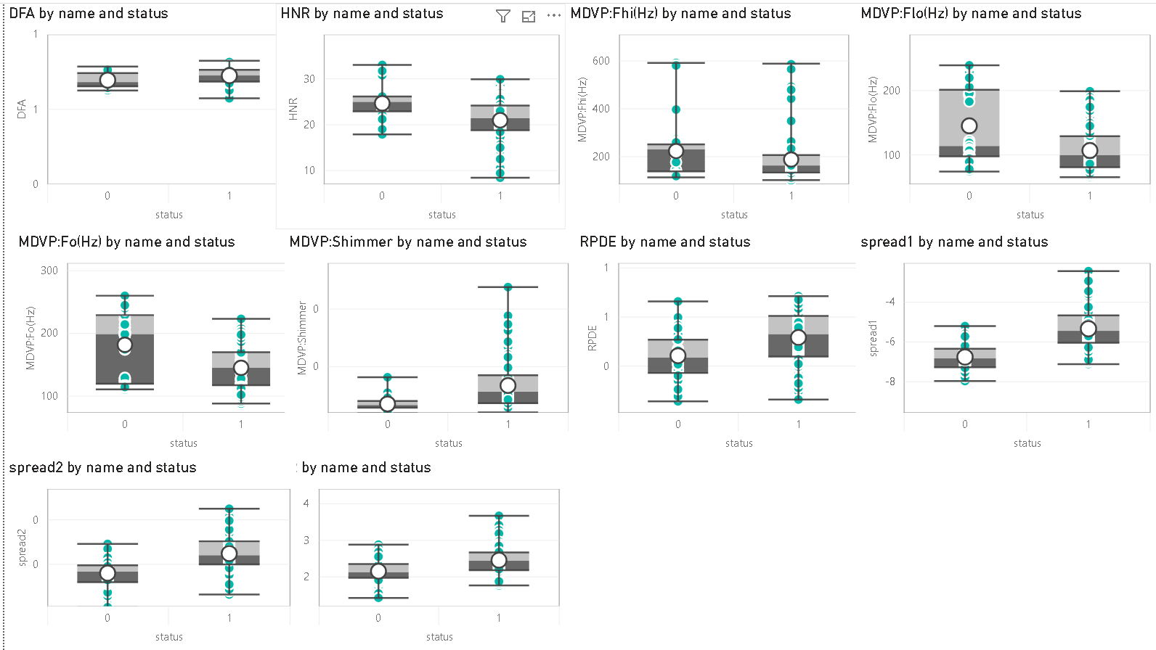

**Figure 1: Comparing range of each attribute by status to see if there is a clear distinction between values for patients with PD and healthy ones.**

**Statistical Analysis:**

**Write fourth (4)**

**Numerical Analysis:**

**Write fifth(5)**

**Conclusion and Summary**

**Write sixth(6)**

**References**

**[1] A. E. Lang and A. M. Lozano, "Parkinson's disease - First of two parts," New England Journal of Medicine, vol. 339, pp. 1044-1053, 1998.**

**[2] A. K. Ho, R. Iansek, C. Marigliani, J. L. Bradshaw, and S. Gates, "Speech impairment in a large sample of patients with Parkinson's disease," Behavioural Neurology, vol. 11, pp. 131-137, 1998.**

**[3] J. A. Logemann, H. B. Fisher, B. Boshes, and E. R. Blonsky, "Frequency and Co-Occurrence of Vocal-Tract Dysfunctions in Speech of a Large Sample of Parkinson Patients," Journal of Speech and Hearing Disorders, vol. 43, pp. 47-57, 1978.**

**[4] J. R. Duffy, Motor speech disorders : substrates, differential diagnosis, and management, 2nd ed. St. Louis, Mo.: Elsevier Mosby, 2005.**

**[5] S. Sapir, J. L. Spielman, L. O. Ramig, B. H. Story, and C. Fox, "Effects of Intensive Voice Treatment (the Lee Silverman Voice Treatment [LSVT]) on Vowel Articulation in Dysarthric Individuals With Idiopathic Parkinson Disease: Acoustic and Perceptual Findings," J Speech Lang Hear Res, vol. 50, pp. 899-912, 2007.**

**[6] D. A. Rahn, M. Chou, J. J. Jiang, and Y. Zhang, "Phonatory impairment in Parkinson's disease: Evidence from nonlinear dynamic analysis and perturbation analysis," Journal of Voice, vol. 21, pp. 64-71, 2007.**